IP 10 PowerPoint Multimedia Presentation
Flipbook Animation

http://www.youtube.com/watch?v=oraONu7Jp_Y&feature=related
- Create a detailed background to set your scene in PAINT and save as a JPEG image
- Insert your picture into Powerpoint
- Choose one object to move that will make another object move (car hitting something, someone hitting someone, hunting, etc)
- NOTE: use the “group” and “ungroup” to move individual parts
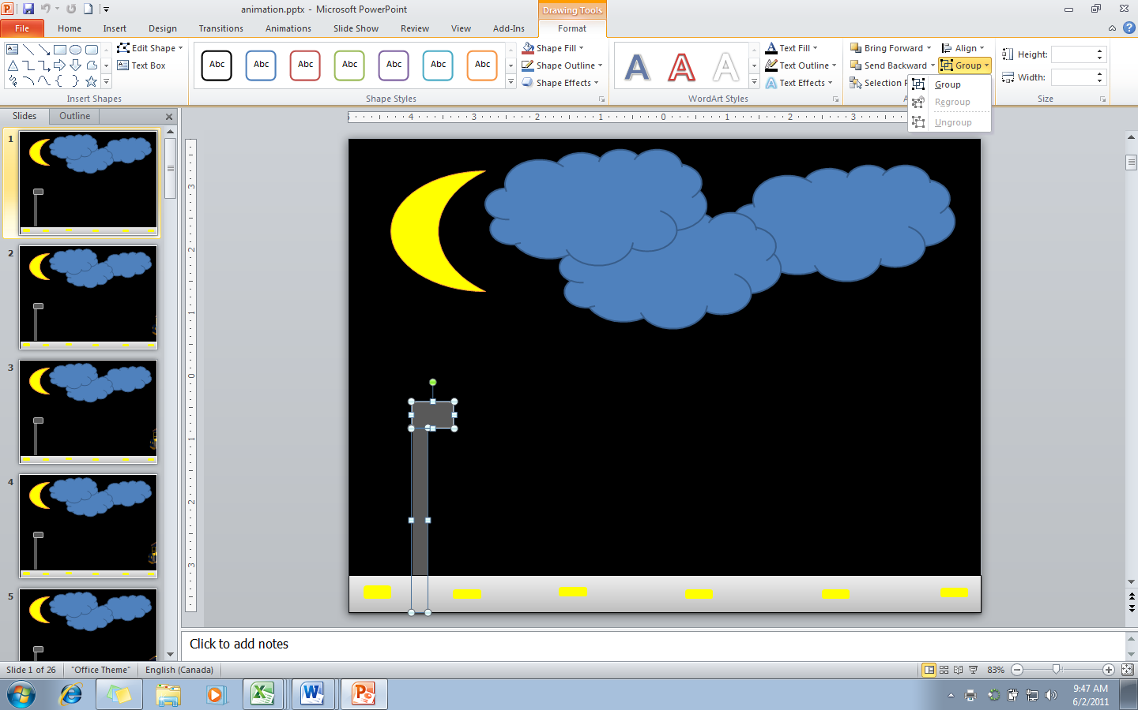
- Duplicate your slide and each slide move the object a small amount
- Do not move to far too fast!!
- Finally, set the Transition option… turn off mouse click and set the timing to 50 seconds to 1 second
- Check your slide show consistently to ensure it is moving smoothly

